Antennas, Propagation, and Path Loss
Electrons moving in a wire generate an electromagnetic field. This field will cause electrons to move in other wires. That’s how radios work. It’s a simple concept, but the details are complicated. If we design the wires so that they are particularly good at transmitting and receiving these electromagnetic fields, then the wires are called antennas.
Any time-varying current will generate electromagnetic radiation. Microprocessor clocks and the digital circuits that they drive turn all of the wires in your computer into a radio transmitter. The current flowing in power lines running your toaster and lights generates plenty of radio waves, as you’ll notice if you try to use an AM radio near them. Even the ultra-low power 32kHz crystal in a wristwatch will radiate on the order of a picoWatt to a nanoWatt.
Electromagnetic waves, or radio waves, travel at the speed of light, c=~300,000km/s. The wavelength λ of a radio wave is determined by the frequency of its oscillation f by the formula
c=f λ
Example: What is the wavelength of AM and FM radio signals?
A: The AM band extends from 500 kHz to 1,500 kHz. 500kHz corresponds to l=3x10^8m/s / 5x10^5 cycles/sec = 0.6x10^3m/cycle, and 1,500kHz is 3 times shorter, at about 200m.
The FM band is from 88MHz to 107MHz. So FM signals have a wavelength of about 3x10^8m/s / 10^8 Hz = 3m

Measuring Power [sidebar box]
Since power in RF systems varies by many orders of magnitude, from transmitters of milliWatts to megaWatts, and receivers able to pick up signals from picoWatts to zeptoWatts, it is usually more convenient to talk about power on a log scale. For this we use Bells, abbreviated B, named for Alexander Graham Bell. One Bell is an order of magnitude in power. We almost always talk about tenths of a Bell, or a deciBell, or decibel. A Bell is a dimensionless unit, so it generally refers to a ratio of powers.
Power gain [dB] = 10 * power gain [B] = 10 log P/Pref
A common reference power is one milliWatt, and measuring in decibels relative to that power level is abbreviated dBm.

If a transmitting antenna radiates a power P_A isotropically in unobstructed space, then the power density, in Watts per meter square, flowing through the surface of a sphere of radius R centered at the transmitter is
S_{i} = P_{T}/4π R²
All antennas have some directional dependence on their transmitted power, so we usually write S as a function of the direction, S(θ,ϕ). The gain of a transmitting antenna is therefore a function of direction as well, and is defined as the ratio of the power density in a given direction to the power density of an isotropic antenna with the same total radiated power.
G(θ,ϕ) = S(θ,ϕ)/S_{isotropic} = 4π R² S(θ,ϕ)/ P_{T}
By definition, the gain of an isotropic antenna is 1. The integral of gain over all angles for an isotropic transmitter is 4π, and it turns out that this is true for all lossless antennas (antennas with loss are worse, i.e. they integrate to less than 4π). Note that in common usage, when people talk about antenna gain they generally quote the maximum gain over all directions. Since the integral of gain over all directions is the same constant for all lossless antennas, if you have high gain in some directions, you will have low gain in others, and if you have a maximum gain of G, then you can’t get that gain over more than 4π/G steradians of the sphere. For example, large parabolic dish antennas for satellite communications have a gain given by
G = (πD/λ)²
where D is the diameter of the dish. Based on diffraction, the theoretical width of that beam is only 1.22 λ/D radians. Beam width in this case is the “full width half maximum” width, meaning the angle over which the antenna will have no less than half its maximum gain.
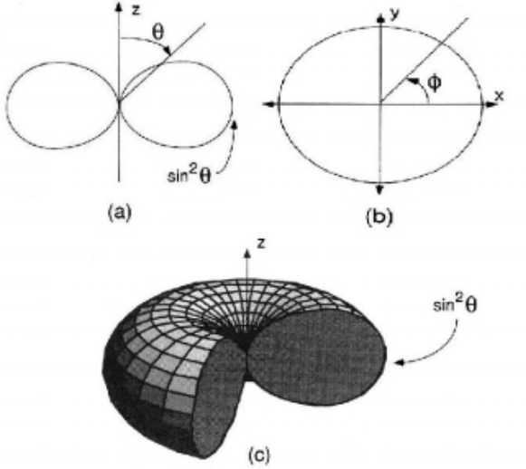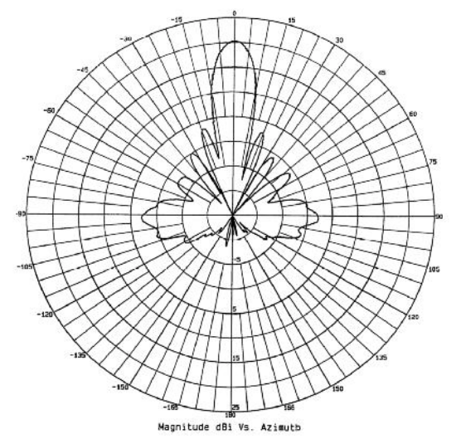Figure 1 Antenna radiation patterns [from X]. Left dipole elevation, azimuth, and 3D rendering. Right: Parabolic dish azimuth.

Now we can calculate the power density at a distance R from a transmitting antenna. The power received by a second antenna is the product of the effective area of the receiving antenna and the power density due to the transmitting antenna,
P_{R} = A_{eff,R} S_{T}(θ,ϕ)
We know what the power density from the transmitter is:
P_{R} = A_{eff,R} G_{T}(θ,ϕ) P_{T} / 4pi R²
The effective area A_{eff}, or cross-section, of an antenna is often very different from its physical area. Using the reciprocity theorem, it can be shown that
A_{eff} = G(θ,ϕ) λ²/4π
And finally we can write down the Friis equation, relating the power received by one antenna to the power transmitted by another antenna at a distance R with no obstructions (in “free space”)
P_{R} = P_{T} G_{T} /(4 π R²) A_{eff} = P_{T} G_{T} G_{R} λ²/(4 π R)²

Example: What is the power received by an isotropic antenna at a distance of 1km from an isotropic antenna transmitting 10mW at 3 GHz?
A: Since both antennas are isotropic, G_{T}=G_{R}=1 . At 3GHz the wavelength is 3x10^8m/s / 3x10^9 Hz = 10cm, so λ²/(4 π R)² = (10⁻¹m)²/(4π * 10³m)² = 6*10⁻¹¹ =
So overall we have 10⁻²W * 6*10⁻¹¹ = 6*10⁻¹³W or just under 1 picoWatt, or -92 dBm
Alternatively, we could do this calculation in dB from the start, where all of the products turn into sums. Noting that 10mW is +10dBm, and 1/(4π)² is conveniently close to -22dB, and our path is 10⁴ wavelengths, we write down
P_{R} = 10dBm + 0dB + 0dB –80 dB -22dB = -92dBm
Note that this is a reasonable amount of power for a low cost, low power receiver to turn into valid data at a few hundred kilobits per second.

Antenna gain and size
Size does matter in antenna design.
An ideal dipole antenna radiates maximum power perpendicular to its axis, and zero power along its axis.
G_{dipole} = 1.5 sin²(θ)
A good dipole can be made from two pieces of wire that are approximately one quarter wavelength each, yielding an antenna that is approximately λ/2 long. Since these wires can be made fairly thin (until their resistance becomes comparable to the radiation resistance of the dipole, which is on the order of 50 Ohms), the area, volume, and cost of this type of antenna can be quite small as well. Such antennas can be printed on plastic with low-cost manufacturing techniques, yielding individual antenna costs of pennies or less in high volume.
For some applications, it is not the volume of the antenna that matters, but rather the largest dimension. If you need to swallow an antenna, you’re less interested in the fact that a printed-film dipole is only a fraction of a cubic centimeter than in the fact that it’s maximum length is 6 cm.
Resonant antennas can be made to be a small fraction of a wavelength in every dimension while still maintaining excellent performance, but this requires that they operate over a small fractional bandwidth. Fractional bandwidth is the frequency range of interest divided by the maximum frequency in the range, Δf/f. For example, the 2.4GHz ISM band in North America extends from 2.4 to 2.485GHz, for a fractional bandwidth of 0.085GHz/2.485GHz or about 3.4%.
The size limit is given by [Siwiak]
Δf/f η = 2 (2πd/λ)³
where 2d is the largest dimension of the antenna, and η is the efficiency. As the antenna gets smaller, the product of fractional bandwidth and efficiency decreases dramatically.
Another problem with shrinking the size of resonant antennas is that their performance becomes very sensitive to the materials near them. Datasheets from companies that sell chip antennas show impressive performance as long as their reference designs are used, where a λ/10 antenna is placed on a ground plane measuring λ/2 square! Often the performance of these antennas degrades by 10dB or more under less ideal mounting conditions.
Moving in the other direction, good antenna gain can be achieved by making larger antennas. The Yagi-Uda antenna is a dipole antenna with two additional conductor wires placed in just the right locations near the dipole, thereby directing the RF energy to/from a particular direction. Antenna gains of 10dB or more are easily achieved with these antennas, but again they become sensitive to the surrounding environment.
If directional antennas of fixed size are used on both ends of a communication link, then in general the received power will increase with increasing frequency, since the gain of both antennas will increase as the square of the frequency, for a product of the fourth power of frequency, whereas the path loss increases only as the square of the increase in frequency.
If dipole antennas are used on both ends, then the received power will decrease with increasing frequency, since the antenna gain will remain constant, but the effective area of the receiving antenna will decrease.

Polarization
Radio waves propagate with orthogonal electric and magnetic fields. Antennas launch and receive radio waves with a particular orientation of these fields. In principle, having your receive and transmit antennas oriented incorrectly can reduce your received signal to zero. In practice, this is not a problem in multi-path environments, but probably reduces the strength of the received signal by 3dB on average.

Propagation, Path loss, and Multipath
Path loss is the power received divided by the power transmitted.
So far we have assumed that there are no obstructions in the between the transmitter and the receiver. In this case, the path loss is just given by the Friis equation assuming the antenna gains are 1,
P_{R}/P_{T} = λ²/(4 π R)²
This is a reasonable assumption for satellite communication, but most sensor networks will operate in environments with lots of obstructions between antennas.
Obstructions cause problems for several different reasons: absorption, reflection, and diffraction. Absorption is straightforward: if the radio wave travels through a wall or floor which absorbs 90% of the energy in the wave, it’s easy to calculate the effect on path loss. Reflection and diffraction are much more complicated in typical environments

Reflections: the two ray model
. The simplest reflection case to analyze is the case of a single reflection off of an infinite plane. This has some relevance to outdoor networks, but even there is of questionable relevance given the assumptions that go into it. Nevertheless, it provides a closed form answer, and you will undoubtedly run into people who tell you that it is “the answer” to the multipath propagation question.
Figure 2 The simplest multipath example. There are two paths between the transmitter at height h₁ and the receiver at height h₂ a distance r away. The first path, p₁, is the direct path. The second takes a single bounce off of a reflective surface.
h₁
h₂
r
p₁
p₂
As shown in Figure 2, two different paths exist between a transmitter and a receiver separated by a distance r above a ground plane. We assume that the size of the antennas is small compared to their heights, and that the separation between the two antennas is large compared to their heights. The difference in the length of the two paths is approximately
δ=p₂-p₁=2h₁h₂/r
The difference in path length is negligible compared to the average, therefore the magnitude of the two waves is almost exactly the same. For shallow reflection angles and a perfect conductor for a ground plane, the phase of the radio wave is inverted by the reflection. So we now have two waves arriving at the receiver with approximately the same amplitude, and approximately opposite phase. These two waves will destructively interfere, giving a much weaker received signal than either one of them individually. Working through the math results in [Rappaport]
P_{R}=P_{T}G_{T}G_{R}h₁²h₂²/r⁴
This fourth-power range dependence is a real effect that is often seen in rural cellular phone systems. Note also that the effect is independent of frequency.
For sensor network deployments, indoor environments are much more complicated geometrically, and outdoor deployments typically have motes lying on the ground where the assumptions of the two ray model are not as cleanly satisfied. But if you stay in the WSN field for a while you will meet people who will swear to you that received power goes as one over r to the fourth, and that they can prove it!
Let’s take another look at the two ray model with different assumptions. Let’s now assume that the ground plane is not an ideal conductor – maybe it’s a dielectric, like sheetrock on a wall or concrete on a floor. Now we can’t say much about how much of the incident wave gets reflected, or about its phase.
E_{LOS} = E₀ sin(ωt)
E_{bounce} = α_{b}E₀ sin(ωt+φ_{b})
Where E_{LOS} is the received line of sight field (with zero phase – we could have picked any constant) and α_{b} and φ_{b} are the amplitude and phase changes introduced by bouncing off of the filing cabinet and traveling an extra meter.
P_{TOT} ~ E_{TOT}² = E₀² (sin(ωt) + α_{b}sin(ωt+φ_{b}))²
Let’s also assume that the distances from the reflector are comparable to the separation between the antennas. Now we are likely to see path length differences indoors that are many wavelengths. A typical office or conference room will have dimensions from 2-20m, or several to several hundreds of wavelengths at frequencies near 1-3GHz. These rooms will have lots of reflections – probably one for each wall, and the floor and the ceiling, as well as filing cabinets, chairs, tables, and people, not to mention multiple bounces! Let’s pick a particular reflection, and assume that it has a path length difference from the line of sight path of 1 meter. Let’s say that the line of sight path is 10 meters, and that the surface that the wave is bouncing off is very reflective – maybe it’s a file cabinet. Between the reflected losses and the difference in path length, let’s assume that the electric field strength of the reflected wave is 90% of the line of sight field strength. If it shows up out of phase, 90% of the line of sight field strength will be destructively interfered with. If the reflected wave shows up in phase, then the receiver will actually get almost twice the field strength of the line of sight path alone. The received power is the square of the field strength, so the variation in power is dramatic: almost 4 times as much power if there’s constructive interference, and 100 times less power if there’s destructive interference!
So how do we know if the interference is constructive or destructive? It depends on the phase of the reflected wave, and it depends on the frequency of the transmission.
φ_{b} = 2π δp/ λ
So a change of a half-wavelength in the reflected path in both directions is all we need to go from max to min and back again.

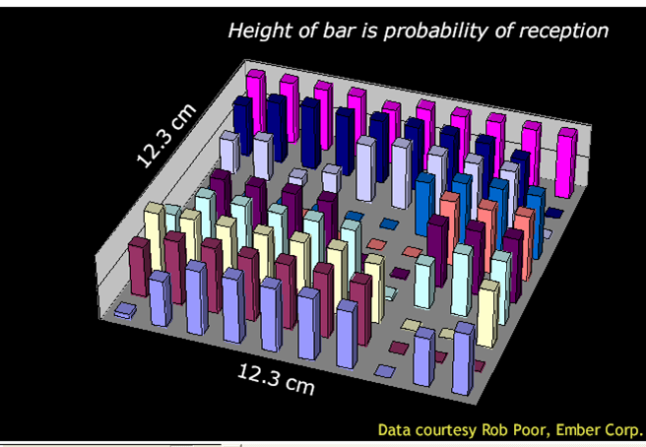
Figure 3 Packet delivery rate vs. receiver antenna position, 802.15.4 2.4GHz, indoors. Plot courtesy of Sam Madden, MIT.
-100
-90
-80
-70
-60
-50
-40
0
20
40
60

P_{R} [dBm]
Distance [meters]
Figure 4 Received power vs. distance, 900MHz, indoors. Red circles are calculated from the Friis equation assuming 1mW TX, 0dBi gain antennas.
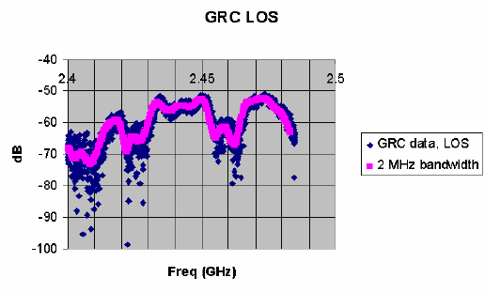From Werb et al.
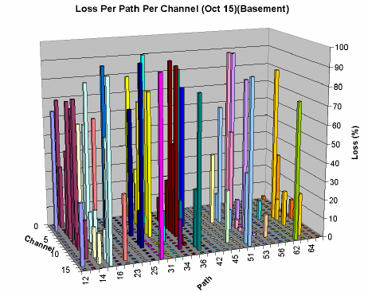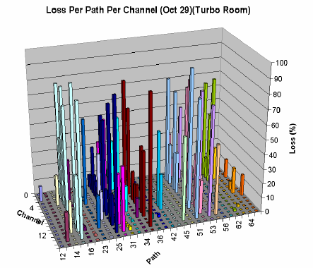Figure 5 Packet error rate for several dozen paths vs. 2.4GHz 802.15.4 channel.

Diffraction: Fresnel zones

Atmospheric attenuation
Radio signals propagating in the atmosphere are attenuated by absorption and by scattering. Over the range of frequencies commonly used for sensor networks, these losses are negligible – less than 0.01 dB per kilometer. There is an interesting phenomenon around 60GHz that may have some bearing on future sensor networks however. Oxygen molecules absorb radiation near 60GHz and convert it to heat. This results in a peak of around 16 dB/km and an average of about 10dB/km of attenuation over the 57-64GHz band defined by the FCC.

Rayleigh Fading

RSSI
References
[Aerocomm] Aerocomm Antenna Tutorial, http://www.aerocomm.com/docs/Antenna_Tutorial.pdf
[Nahin] Paul J. Nahin, The Science of Radio, Springer, 2001.
[Siwiak] Siwiak, “Radiowave Propagation and Antennas for Personal Communications” 1998
[Rutledge]

Exercises
- Without using a calculator, determine the gain in Bells:
  - 10,
  - 1/10,
  - one thousand, one thousandth
  - one millionth, one millionth (on part per million, or ppm)
  - a google (10^100)
- Without using a calculator, determine the gain in dB
  - 2, 20, 0.2, 2 million, 2 parts per million
  - 4, 40, 0.4
  - 8
  - 5, 50, 0.5, 5 thousand, 5 thousandths
  - 2.5, 25, 0.25
- Calculate the received power from the Cassini spacecraft when transmitting from Saturn (1.5 billion kilometers) using a 4m diameter antenna at 20W and 8.4 GHz to a 70 meter diameter dish antenna receiver?
- What is the antenna gain of a DirectTV antenna? Assume that it is 50cm across, and receiving signals at 12GHz. How accurately do you need to point it?
- What is the path loss from low earth orbit to the surface of the earth at 2.4GHz? Assume a 300km orbit and a 45 degree angle.
- How big is the antenna on your car stereo compared to the AM and FM wavelengths that it is receiving? What does that tell you about the bandwidth of the antenna?
- Assume that you have two motes talking to each other in a conference room. The direct path is 3 meters, but the direct path goes through a conference table which attenuates the signal by 10dB. There is a single bounce path with no obstructions. What length must the single bounce path have in order for it to have the same signal strength as the (attenuated) direct path? Assume isotropic antennas.
- Two dipole antennas are in the same plane and separated by 10 meters. They have a direct path between them that hits each dipole at 45 degrees from it’s axis. A second multi-reflected path hits each dipole perpendicular to its axis. Assuming perfect reflections, what path length on the reflected path results in a received signal strength equal to the first path?
- What is the smallest resonant antenna that could theoretically have 10% efficiency over the 2MHz width of a single 802.15.4 channel at 2.45GHz?
- To simulate the effect of multiple random paths summing at the receive antenna, use matlab to randomly generate a thousand sets of 5 complex numbers with magnitude uniformly distributed between 0 and 1. Add each set together and add 1. Plot a histogram of the magnitude of the sum. Try different distributions and numbers of paths.

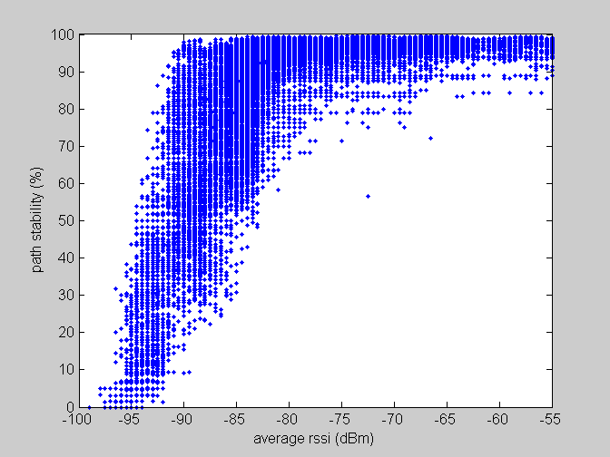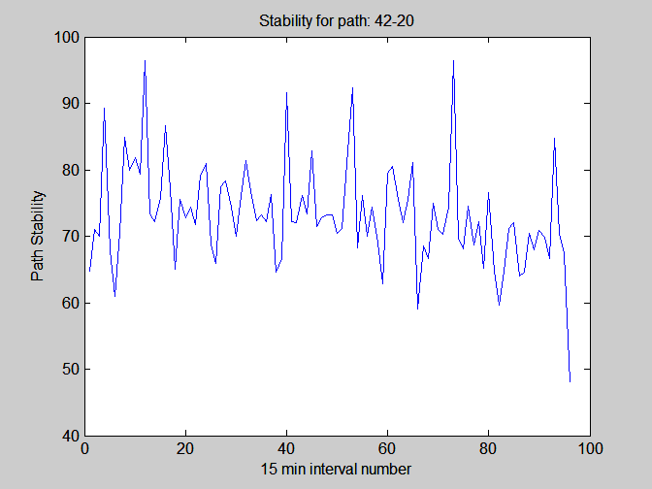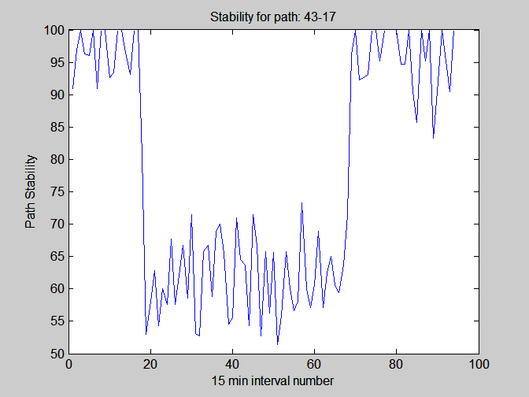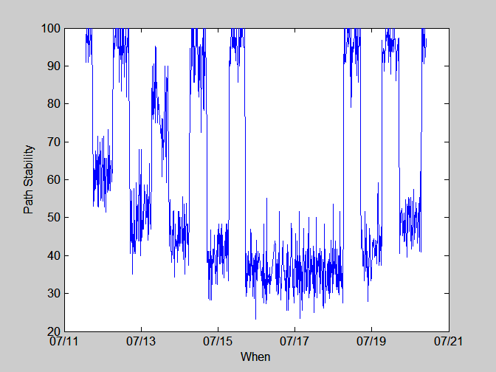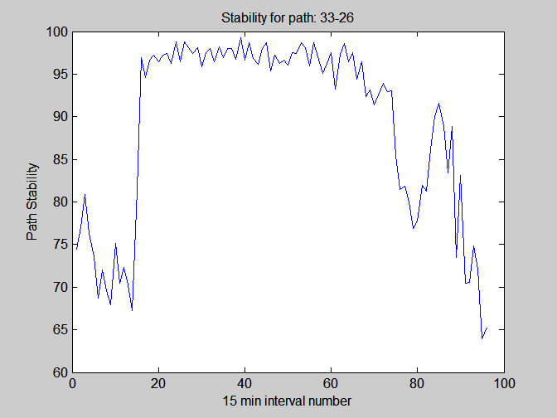

See, for example, Rutledge

